GAMR3531 Report Template
Repo URL: | https://github.com/GAMR3531/cw26-beani3/tree/ECS |  |  |  | Commit: | e36fdc849ec588d97091d0ffe0e4424a5ca6ac15
Tick all parts of the submission that this report covers:
GPU | Profile run and documented but no changes made. | All redundant binding of GPU buffers and shaders removed. Profile run and documented for this change. | Successfully Implement either a depth-pre pass or move to deferred or tiled rendering. Profile run and documented. | Successfully Implemented a LOD scheme. Profile run and documented. | Successfully Implemented instanced rendering. Profile run and documented. | Rewrite the Bloom effect in compute shaders or GPU side frustum culling in a compute shader.  Profile run and documented. | Innovation beyond the specification.
 | ☐ | ☐ | ☐ | ☐ | ☐ | ☐ | ☐
CPU | Profile run and documented but no changes made. | Replace polymorphic games object with composable game objects.  Profile run and documented. | Minimised memory footprint of all classes.  Improve memory use of UBO/UBOManager. Profile run and documented. | Successfully implemented SIMD collision checks (beyond default/GLM optimisation) or CPU side frustum culling.  Profile run and documented. | Successfully Implemented a spatial partitioning scheme for broad phase collision checks. Profile run and documented. | Manually manage all RAM allocations with a sensible scheme.  Profile run and documented. | Innovation beyond the specification.
 | ☐ | ☐ | ☐ | ☐ | ☐ | ☐ | ☐
What change(s) have you made: |  | Changed from game objects to an entity component system.
Which tools have you used to provide evidence for the change(s) you have made? |  | ☐ | Tracy
 |  | ☐ | RenderDoc/NSight
 |  | ☐ | Custom instrumentation
 |  | ☐ | Other (please state)
Put your Evidence here:  Lemon: ECS  Ruby: Base profile  Green : ECS profile gaussian plot.  Red : Base profile gaussian plot. |  | 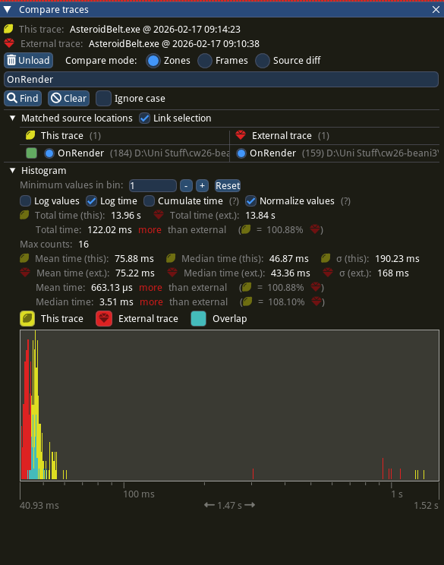  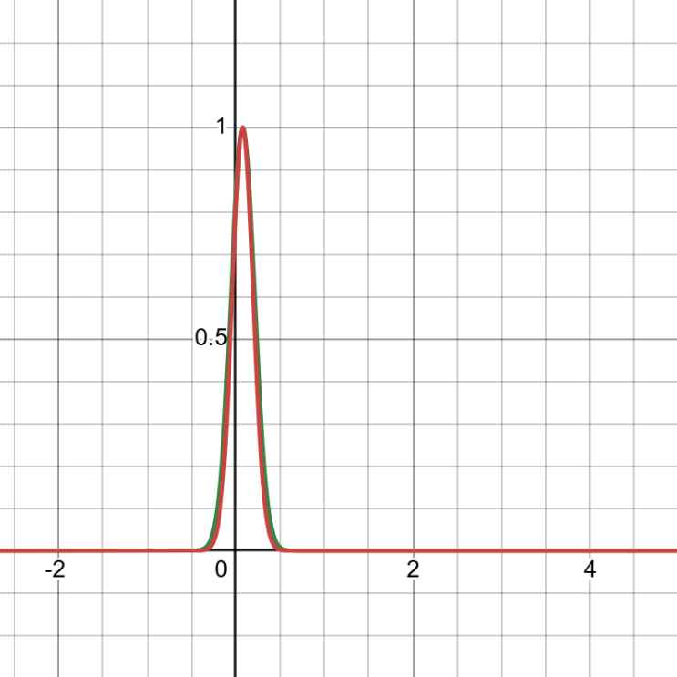  Figure 1: OnRender() comparison data  Figure 2: OnRender() standard deviation gassian plot  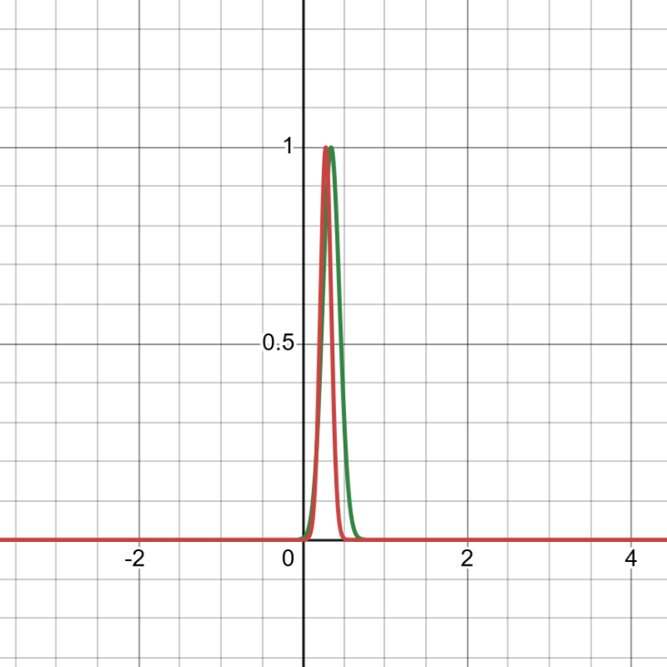  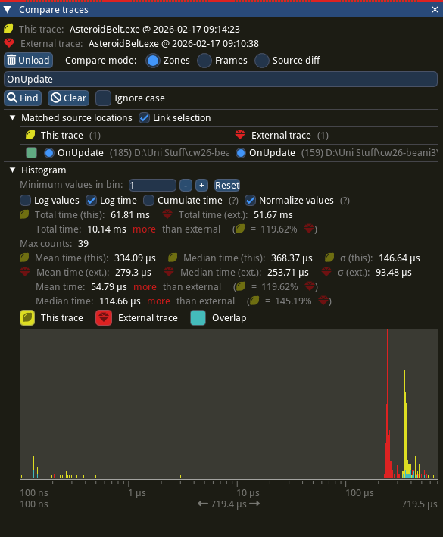  Figure 3: OnUpdate() comparison data  Figure 4: OnUpdate() standard deviation gaussian plot  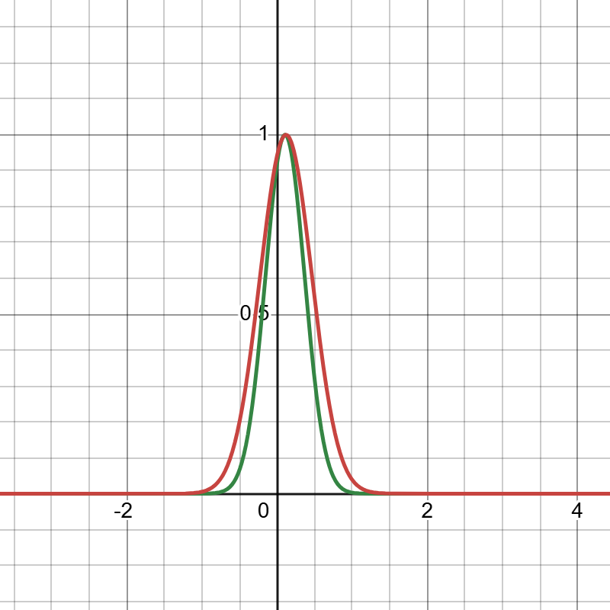  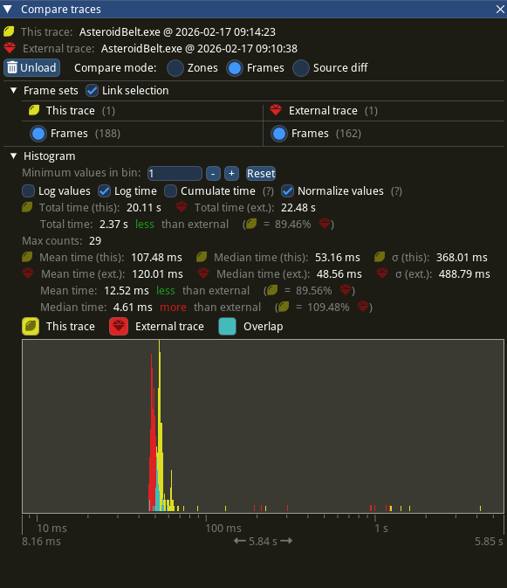  Figure 6: Overall comparison standard deviation gaussian plot  Figure 5: Overall comparison data
Anything else you want to add? |  | From analysis and comparison of the data, I’ve come to the conclusion that the performance gain from implementing ECS is negligible. This is particularly apparent when comparing the two data sets from the OnRender function(). However, a data set that seems to be anomalous is OnUpdate() which seems to indicate that things have worsened since implementing ECS. I’ve done some digging and thinking and cant seem to come up with a reason for why this is the case.

